ISI
di BARGA

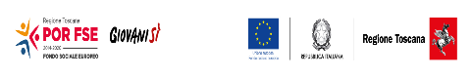
CONCORSO “Dolcidee”
La/ Il sottoscritta/o ________________________________________ frequentante la classe ______ dell’ISI di Barga in qualità di partecipante al Concorso Dolcidee
DICHIARA
Di aver preso integrale visione del regolamento
Che il proprio dolce: Tipo “biscotti”
Nome dato al biscotto ________________________________
SCHEDA BISCOTTI
Ingredienti: ________________________________________________________________ ________________________________________________________________ ________________________________________________________________ ________________________________________________________________ ________________________________________________________________ ________________________________________________________________
Procedimento:
________________________________________________________________ ________________________________________________________________ ________________________________________________________________ ________________________________________________________________ ________________________________________________________________ ________________________________________________________________ ________________________________________________________________

Nome Biscotti: _______________________ Data consegna _____________
(riservato all’ufficio scolastico)

